**DDL (DATA DEFINITION LANGUAGE):**

DDL, or Data Definition Language, is a subset of SQL (Structured Query Language) used to define and manage the structure of a database, including tables, schema, and constraints. The primary commands that fall under DDL are:

* CREATE
* ALTER
* DROP

CREATE: This command is used to create database objects like tables, indexes, views, and stored procedures.

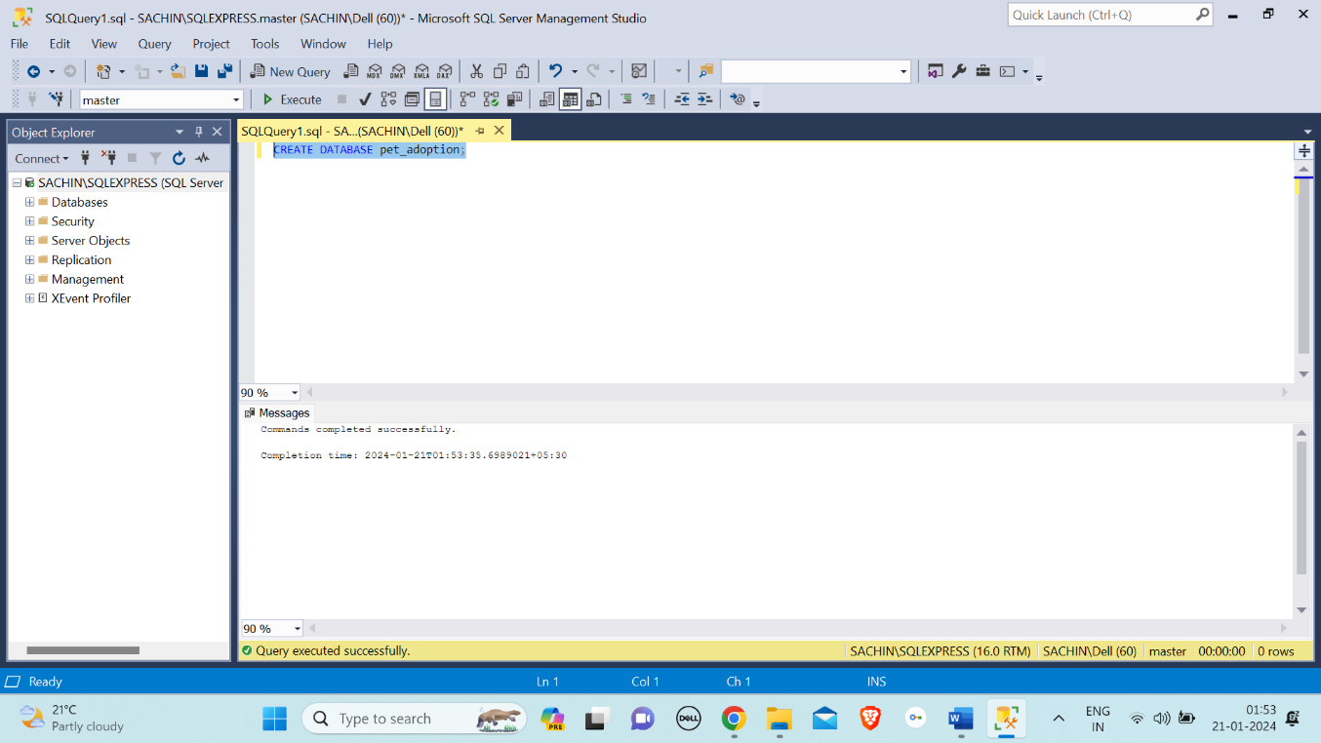

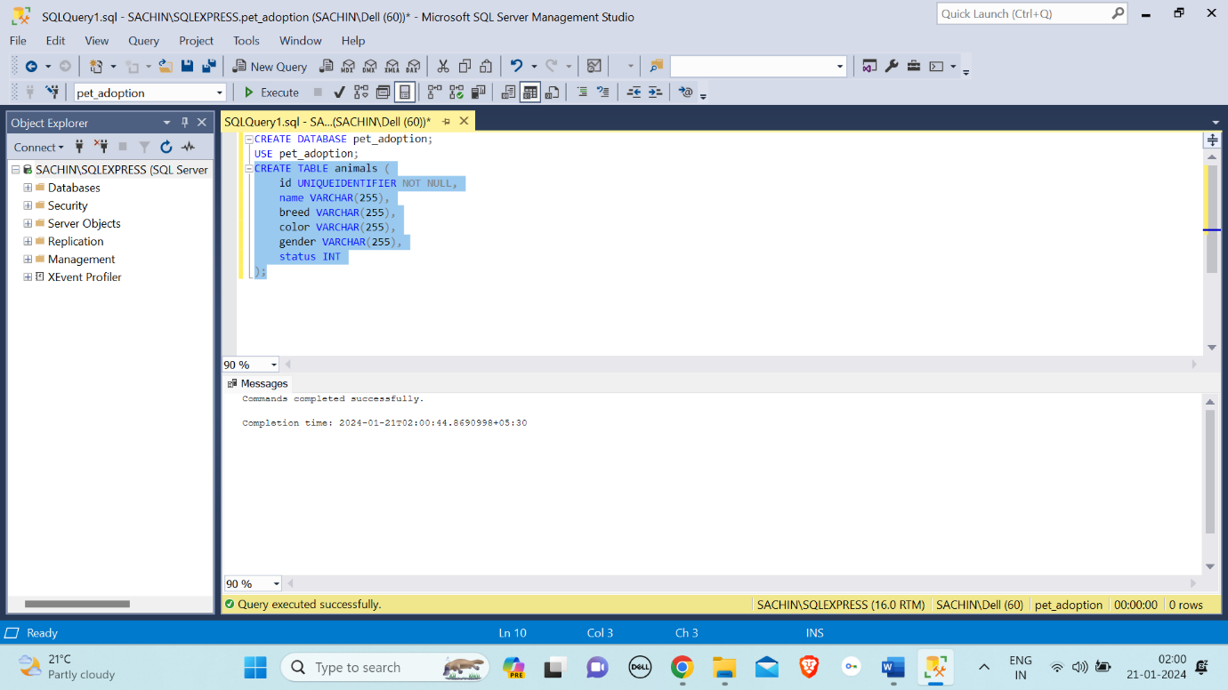

ALTER: The "ALTER" command in SQL is used to modify the structure of existing database objects, such as tables, by adding, modifying, or dropping columns or constraints.

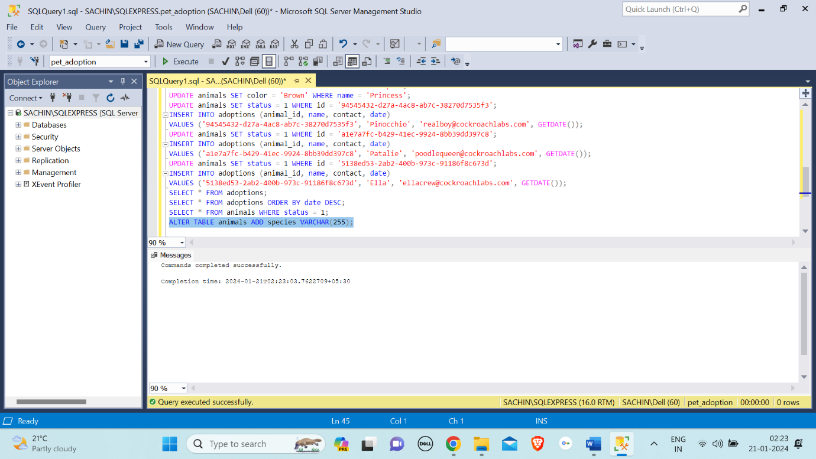

DROP: The "DROP" command in SQL is used to delete or remove a database object, such as a table, view, index, or schema.

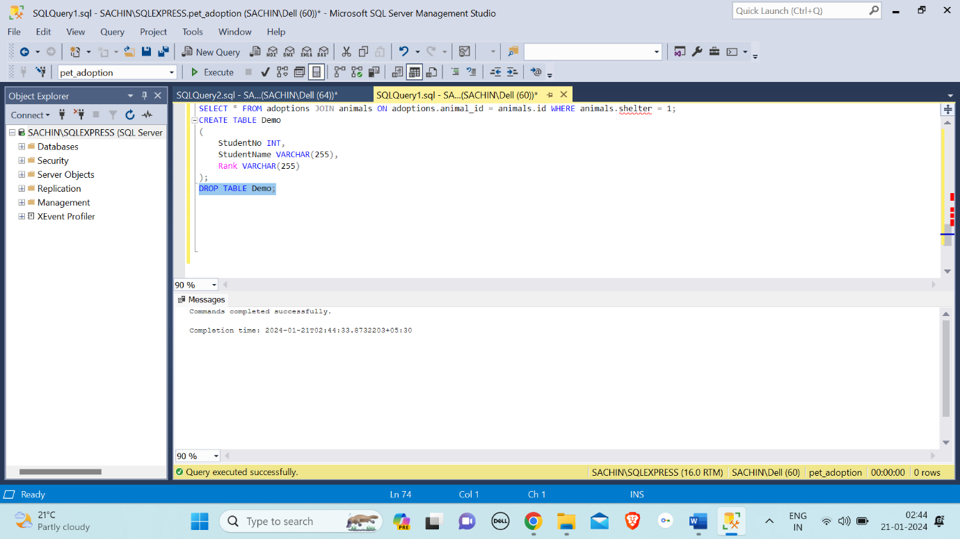

**DML (DATA MANIPULATION LANGUAGE):**

DML, or Data Manipulation Language, consists of a set of SQL commands that allow users to manipulate data stored in a database. The primary DML commands include:

* SELECT
* INSERT
* UPDATE
* USE

SELECT: The "SELECT" command in SQL is used to retrieve data from one or more tables in a database.

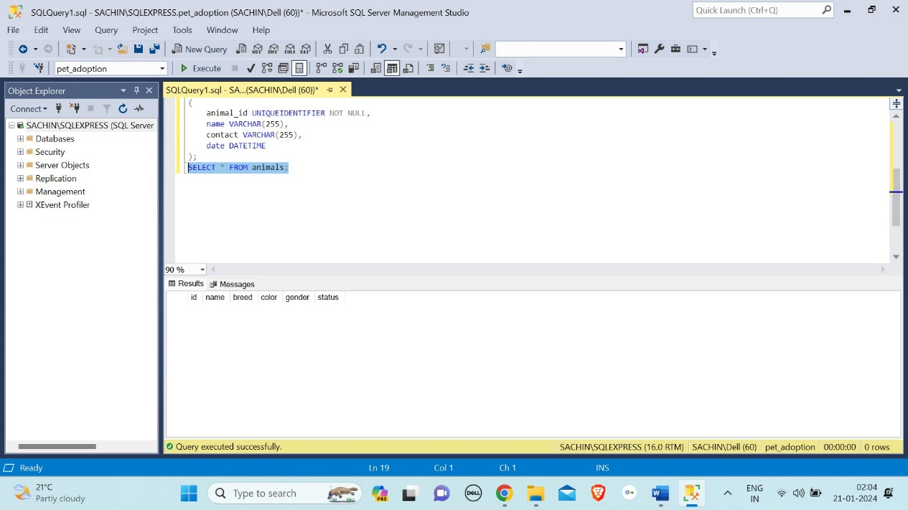

INSERT: The "INSERT" command in SQL is used to add new records (rows) into a table.

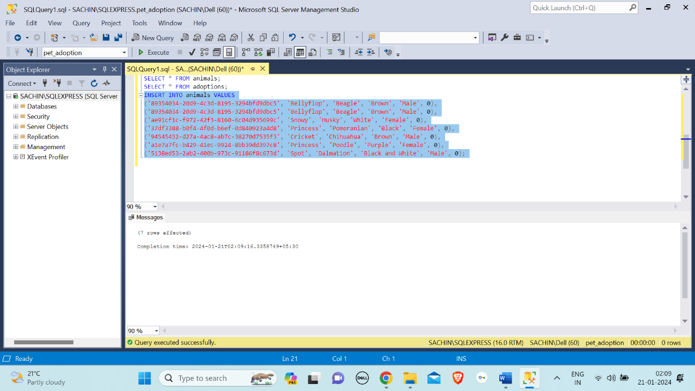

UPDATE: The "UPDATE" command in SQL is used to modify existing records in a table by changing the values of specified columns based on a specified condition.

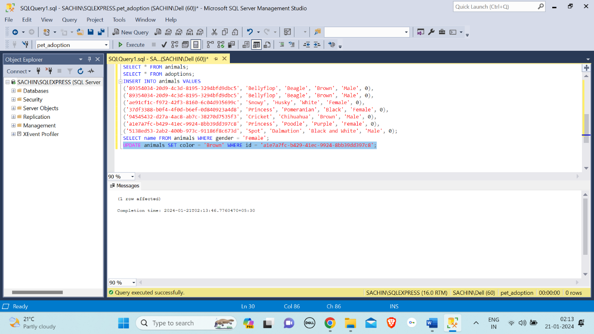

USE: The "USE" command in SQL is used to set the current database context, specifying the database on which subsequent queries and operations will be performed.

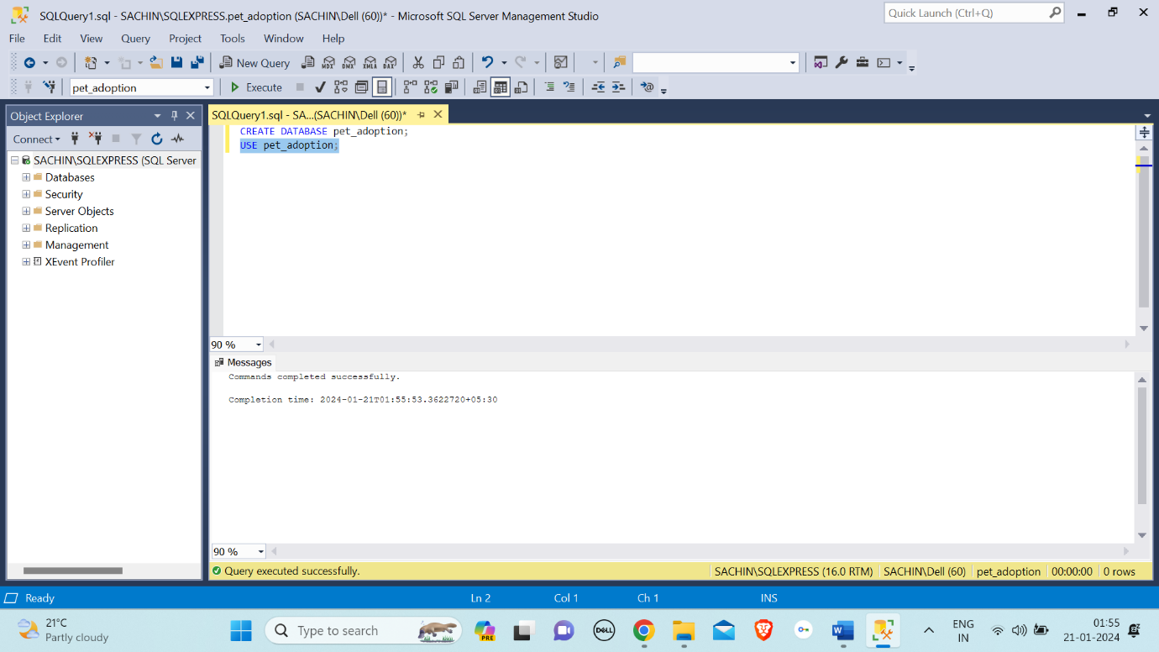

**JOINS:**

SQL Join statement is used to combine data or rows from two or more tables based on a common field between them. Different types of Joins are as follows:

* INNER JOIN
* LEFT JOIN
* RIGHT JOIN
* FULL JOIN

Inner Join: Returns only the rows that have matching values in both tables.

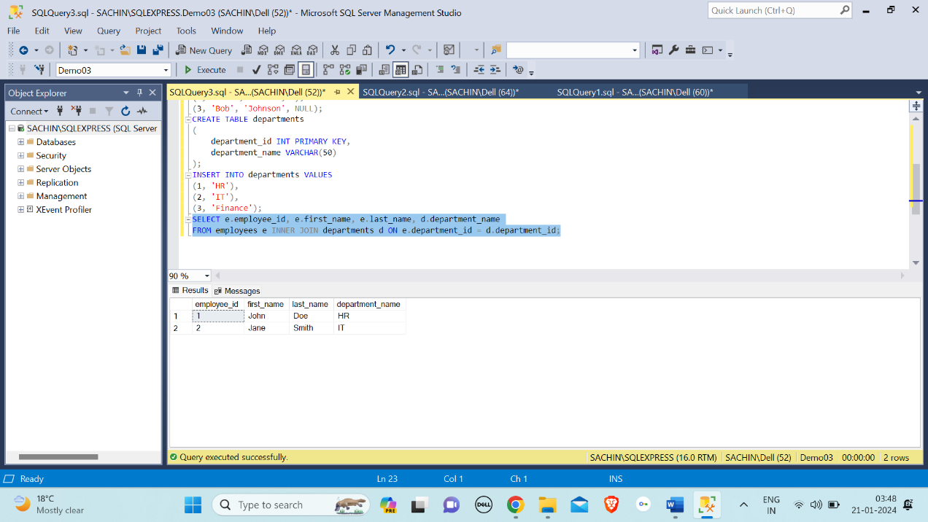

Left Join (or Left Outer Join): Returns all rows from the left table and the matched rows from the right table. If there is no match, NULL values are returned for columns from the right table.

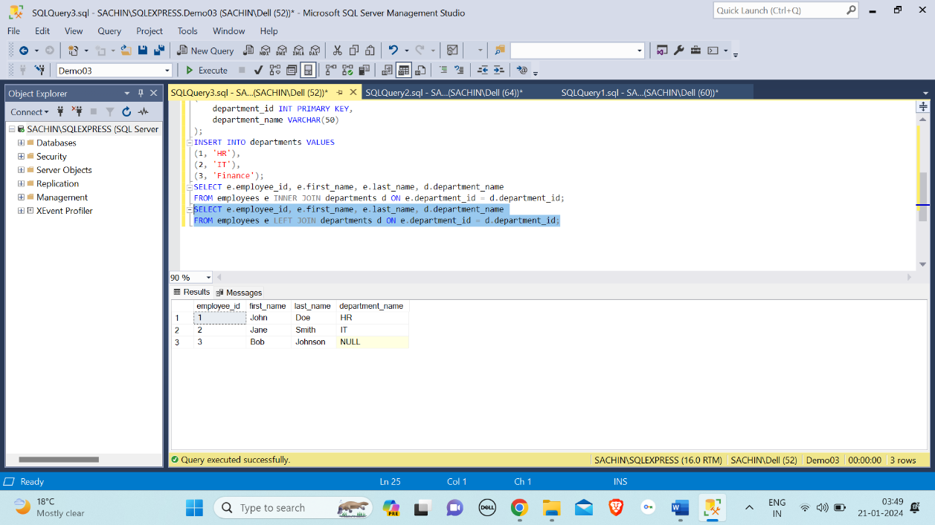

Right Join (or Right Outer Join): Returns all rows from the right table and the matched rows from the left table. If there is no match, NULL values are returned for columns from the left table.

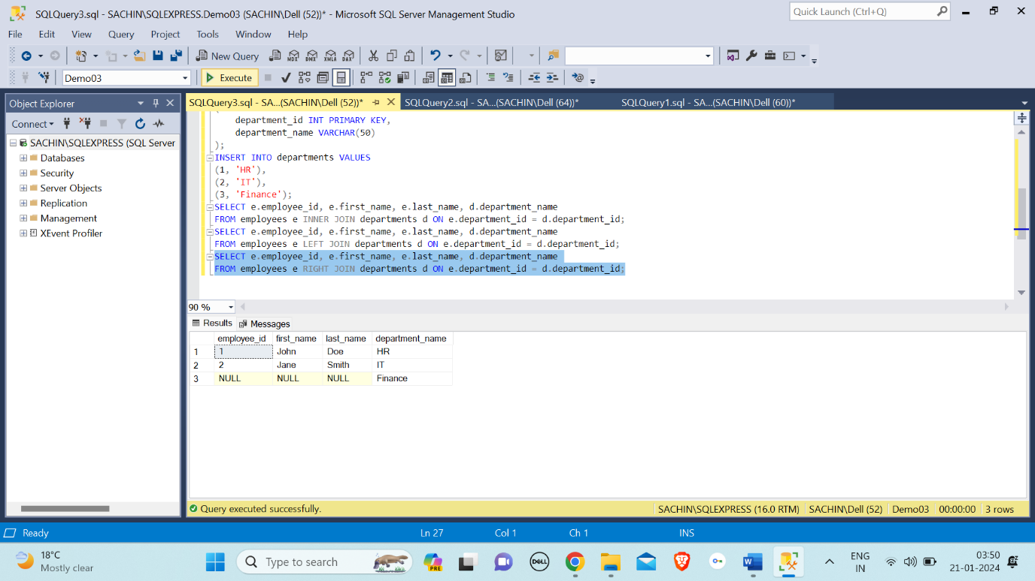

Full Join (or Full Outer Join): Returns all rows when there is a match in either the left or right table. If there is no match, NULL values are returned for columns from the table that doesn't have a match.

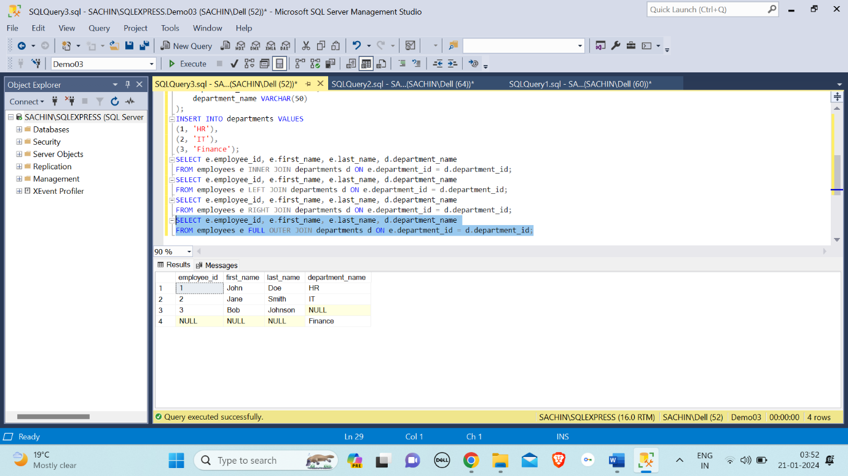

**OPERATORS:**

AND Operator: The AND operator is used to combines two or more conditions but if it is true when all the conditions are satisfied.

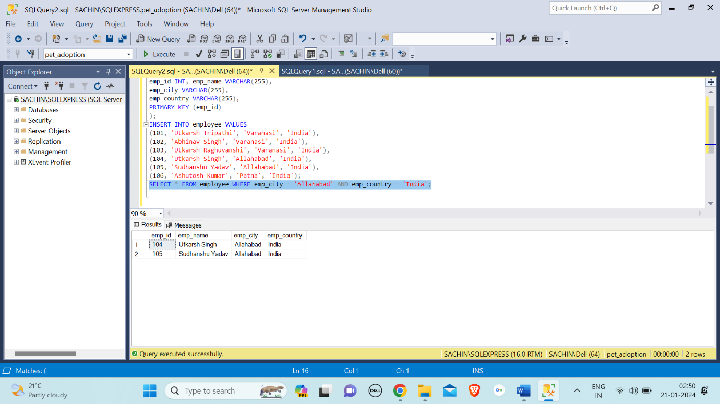

IN Operator: The "IN" operator in SQL is used to filter results by specifying a list of values, and it returns rows where a specified column's value matches any value in the provided list.

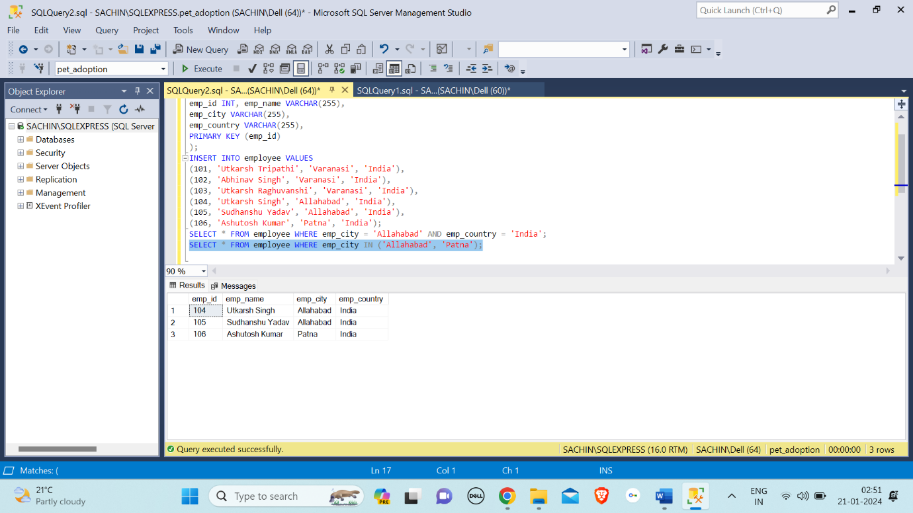

NOT Operator: The "NOT" operator in SQL is used to negate a condition, returning rows that do not satisfy the specified condition.

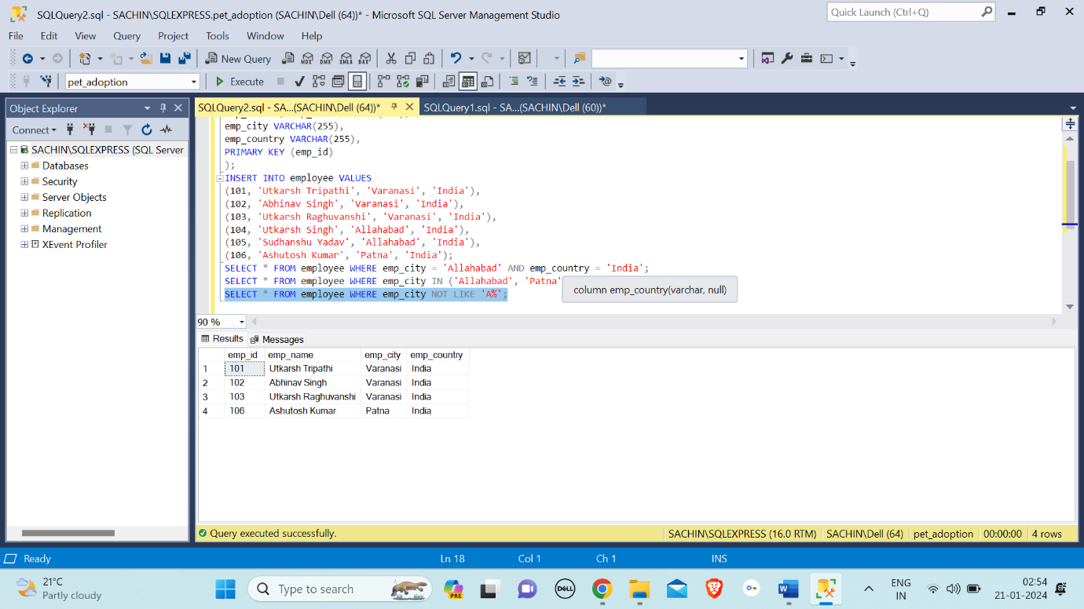

OR Operator: The OR operator is used to combines two or more conditions but if it is true when one of the conditions are satisfied.

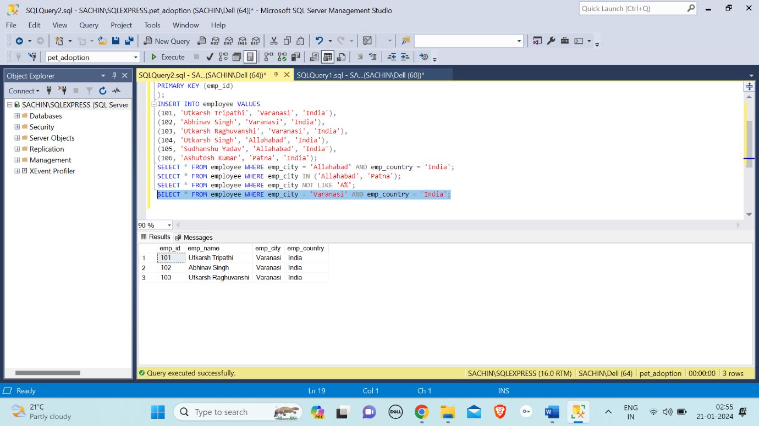

LIKE Operator: The "LIKE" operator in SQL is used to search for a specified pattern in a column, allowing the selection of rows that match the pattern.

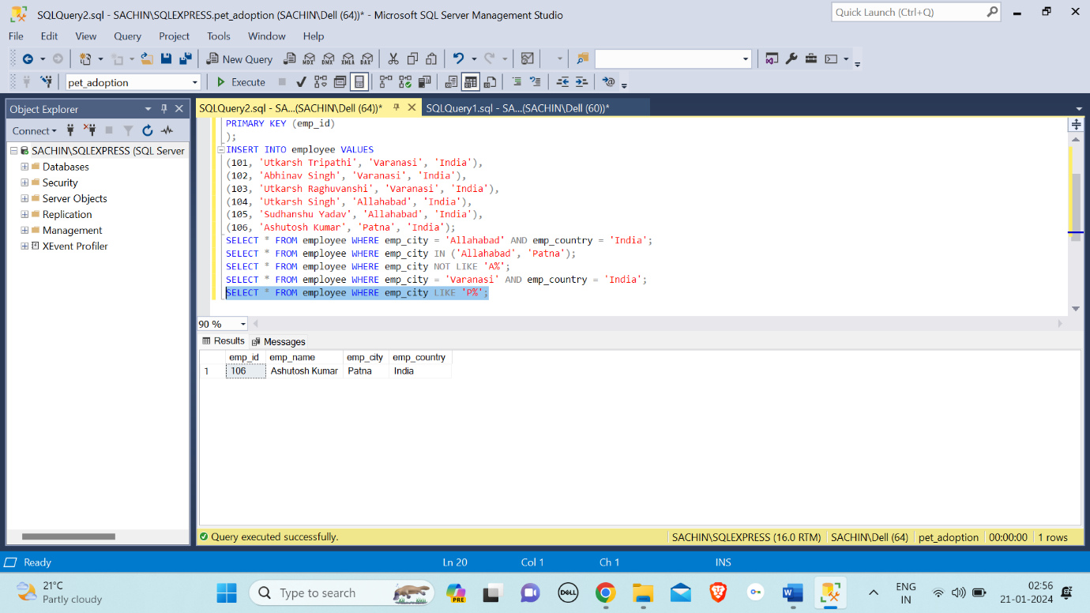

BETWEEN Operator: The "BETWEEN" operator in SQL is used to filter query results based on a specified range of values for a given column.

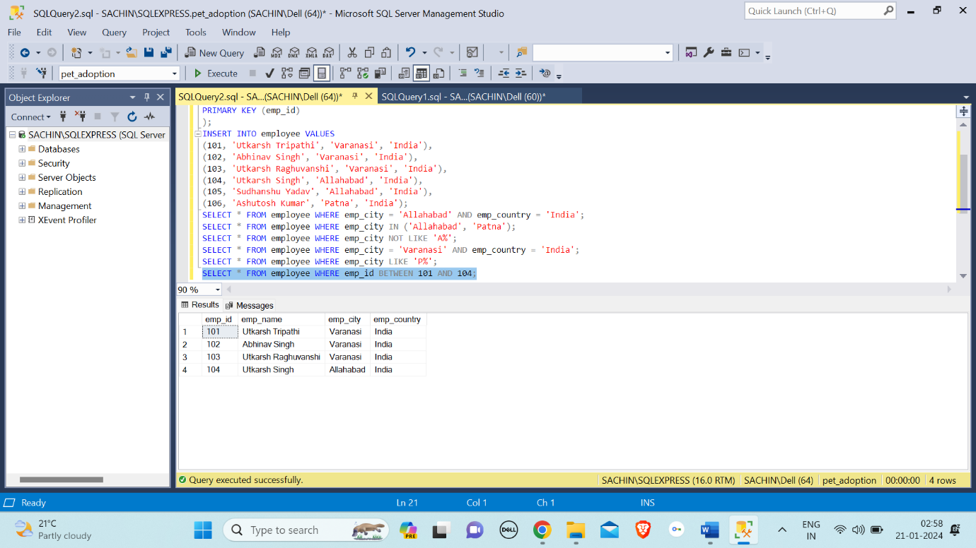

ALL Operator: The ALL operator returns TRUE if all of the subqueries values matches the condition. All operator is used with SELECT, WHERE, HAVING statement.

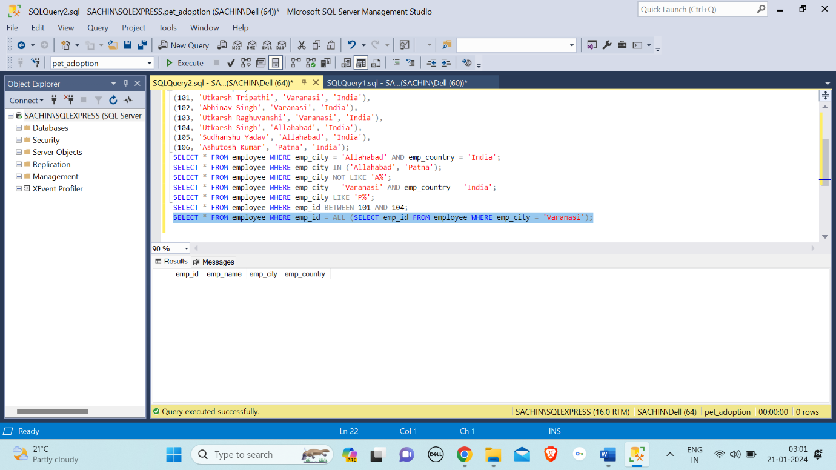

ANY Operator: The "ANY" operator in SQL is used to compare a value to any value in a set of results returned by a subquery.

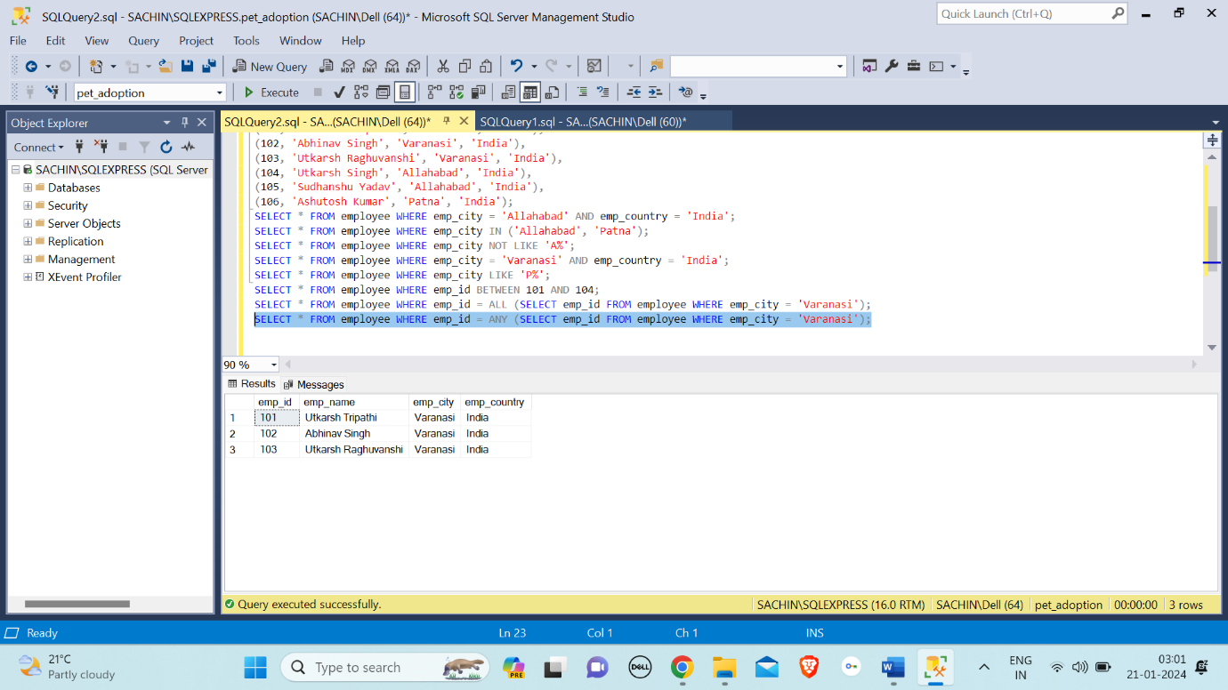

EXISTS Operator: The "EXISTS" operator in SQL is used to check whether a subquery returns any rows and returns a Boolean value (True or False) based on the existence of those rows.

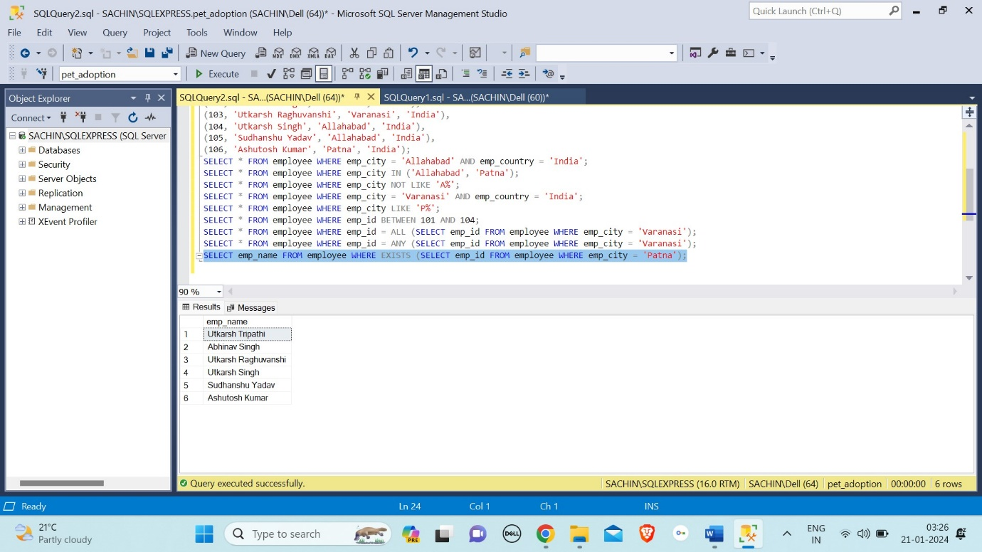

SOME Operator: SOME operators are issued with comparison operators (<,>,=,<=, etc) to compare the value with the result of a subquery.

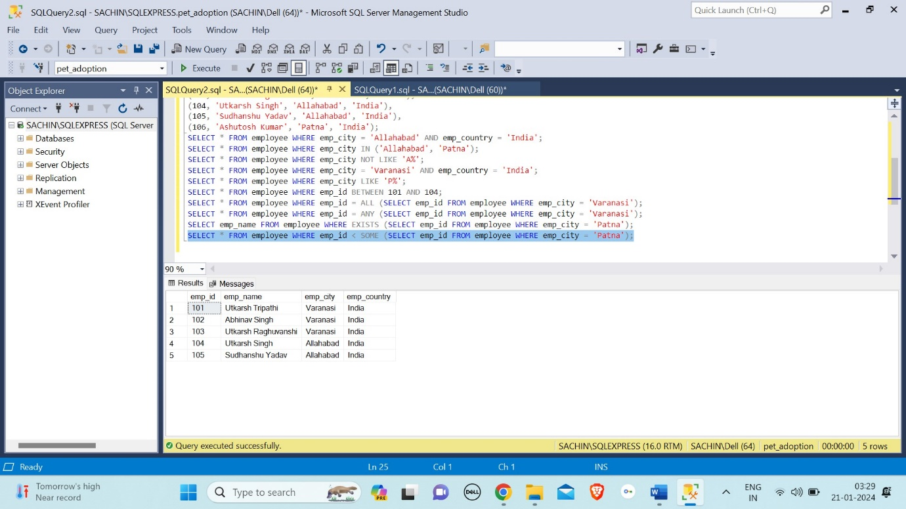

WHERE CLAUSE: The "WHERE" clause in SQL is used to filter records in a query based on specified conditions, allowing you to retrieve only the data that meets certain criteria from a table.

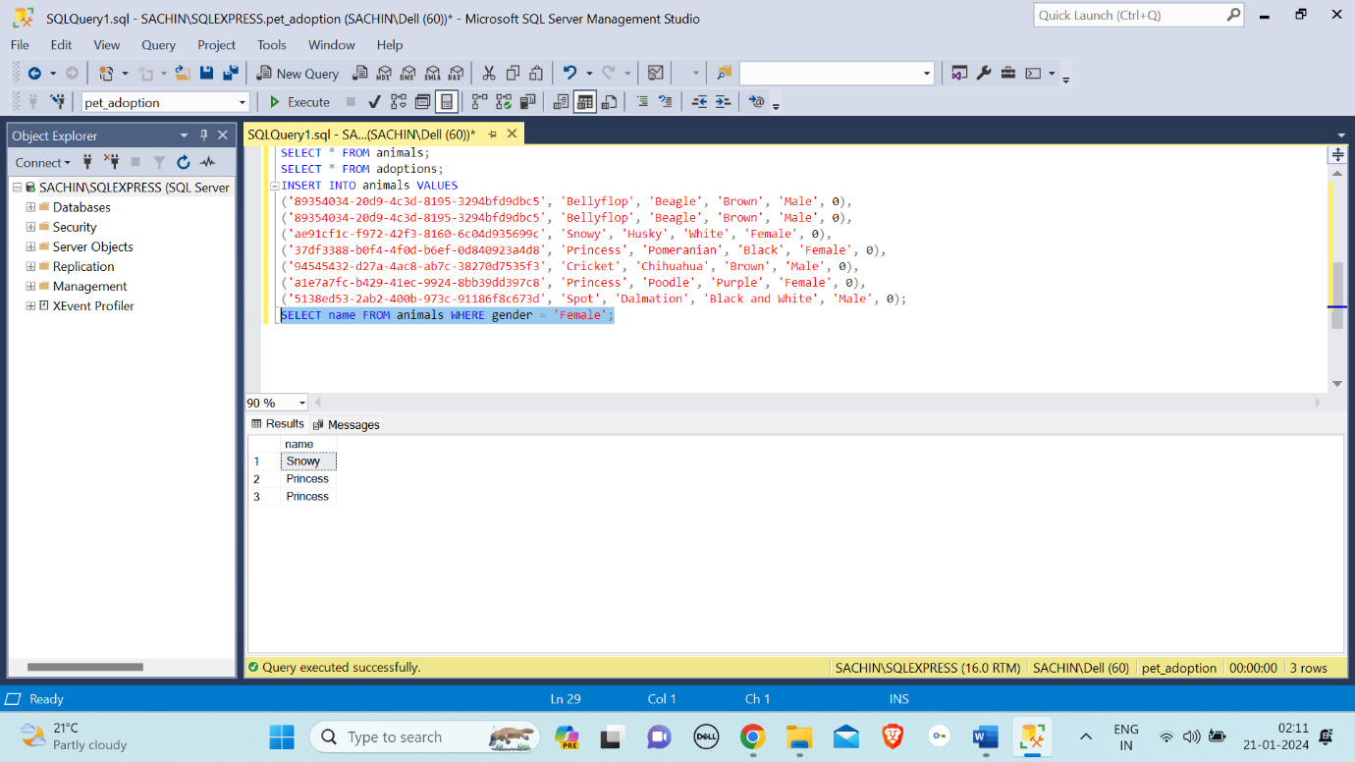

ORDER BY: The "ORDER BY" command in SQL is used to sort the result set of a query based on one or more columns in ascending or descending order.

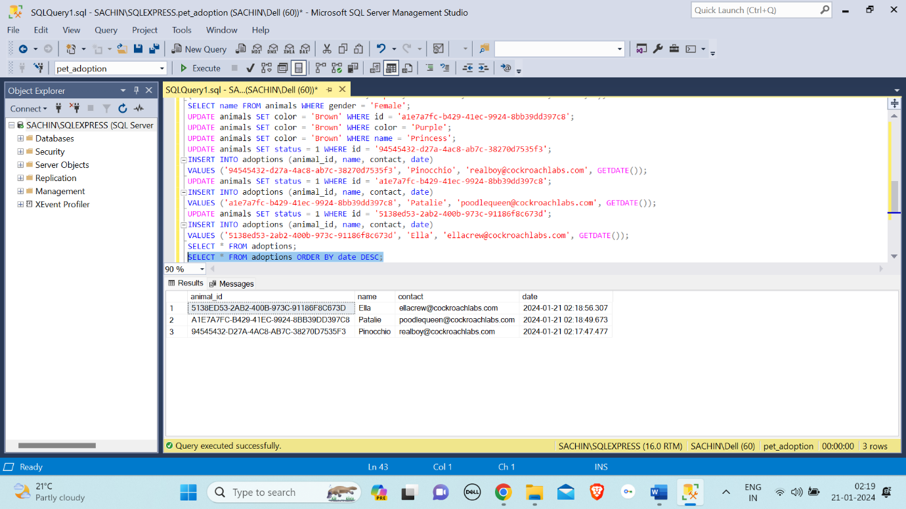

SET: The "SET" command in SQL is used to modify the session-level settings, such as changing the behaviour of the query optimizer or adjusting the display settings for result sets.

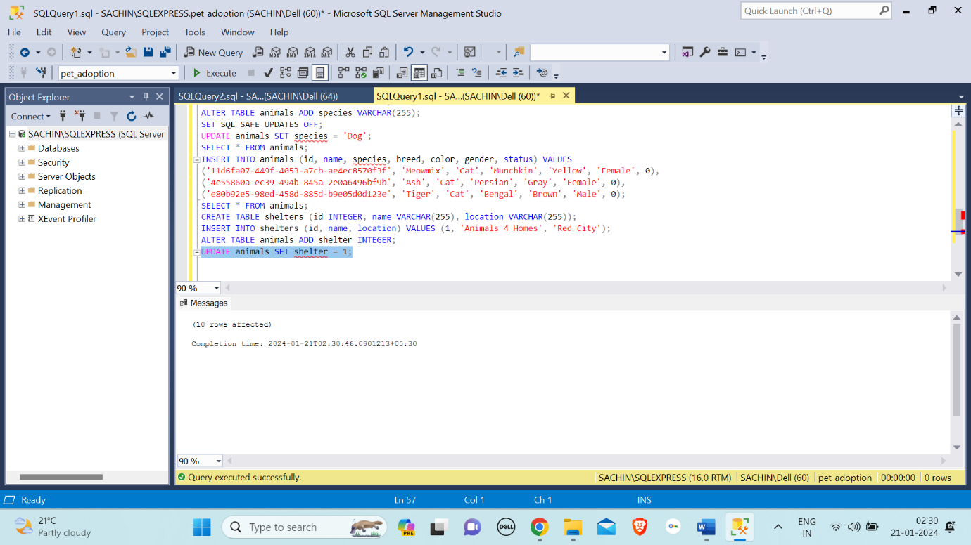

INDEX: The "INDEX" command in SQL is used to create an index on one or more columns of a database table, enhancing query performance by facilitating faster data retrieval.

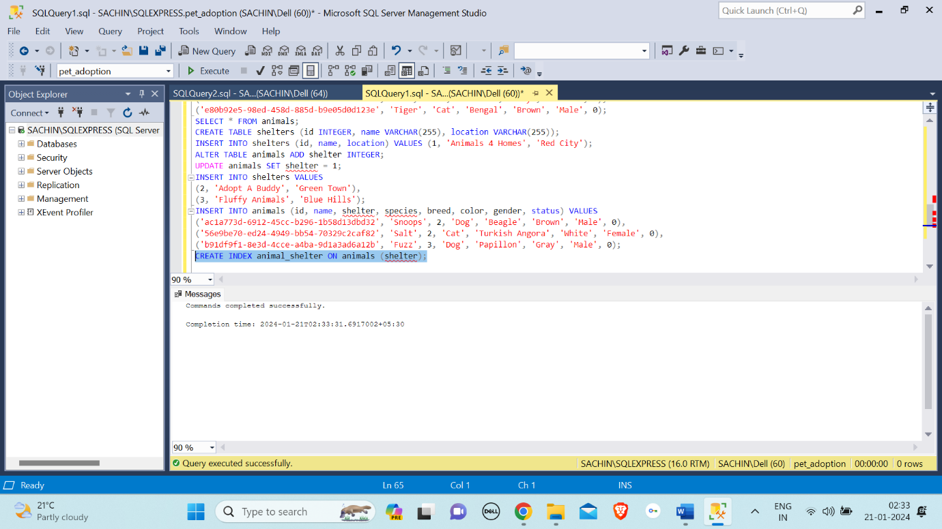

ON: In SQL, the "ON" command is primarily used in conjunction with clauses such as JOIN conditions to specify the criteria for combining rows from different tables.

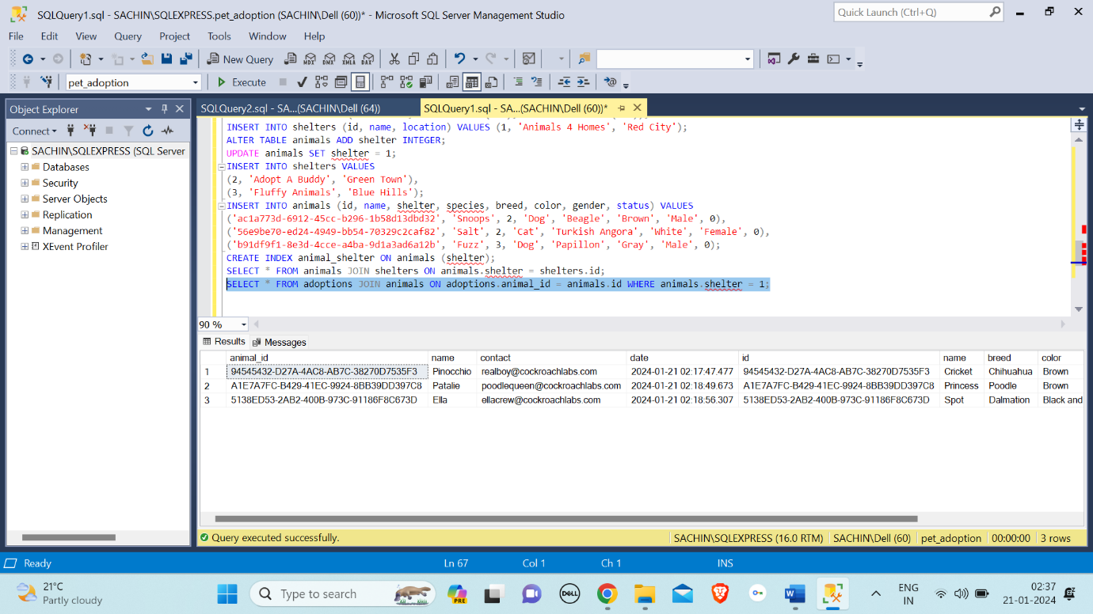

DISTINCT: The "DISTINCT" operator in SQL is used to retrieve unique values from a specific column in a result set, eliminating duplicate entries.

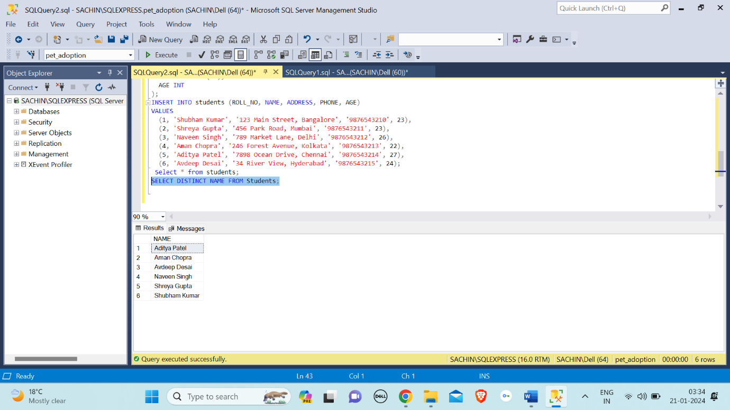

COUNT() Function: The "COUNT" operator in SQL is used to count the number of rows that meet a specified condition in a table or result set.

